Intro to ITWS

Project and Problem Proposal

10-7-13

Ryan Dolan, Matt Hamlin, Natalie Lockhart

Three Words Game

Purpose: This application offers a simple way to relax while bolstering the creativity of its users. Users will have the chance to indirectly work together to make a story with limited information. Alternatively, users may choose to spectate a group of users working together, and submit ideas for them to work off of.

Users: Anyone who wants to play a quick, simple game with other anonymous users online, or anyone looking for creative inspiration.

Idea: Users will anonymously work together to create a story for fun. The application will cycle through each user, display the words entered by the previous user, and allow the current user to add three words to the sentence. Other users that are not participating in writing the story may see the entire story, while users in the editing queue can only see the words entered by the user that went right before them. Users spectating can suggest topics to those editing. After a certain time period has passed, the story editing process will conclude and all users will be allowed to see the final creation.

Design: When loading the application, the user would have an option to spectate a story or to edit a story page 1). Upon choosing an option, the user is directed to a page with a random group of users working on a unique story. If the user chose to spectate, they would be able to see the story in its entirety, and they would also be able to suggest one or two word ideas to the users writing the story (page 2).

If the user chose to edit a story, they would be directed to a page with a timer and a text entry field (page 3). The timer would count down until zero, at which time the user would be shown the previous three words another user had written, and the user would have up to ten seconds to write up to five words to continue the sentence. At the end of the time (or when the user chooses to submit), the entry would be checked to ensure it fits within the game rules. After the maximum game time has been reached, the story will be shown to each writer.

Primary Area: HTML and CSS for page layout and design

Secondary Area: Javascript

1. Creating a timer that tells the users how long they must wait until it’s their turn to contribute to the story
2. Checking the user input and warning the user when a sentence needs to end
3. Displaying subject suggestions from other users
4. Possibly customization of game rules

Page 1 – Landing page

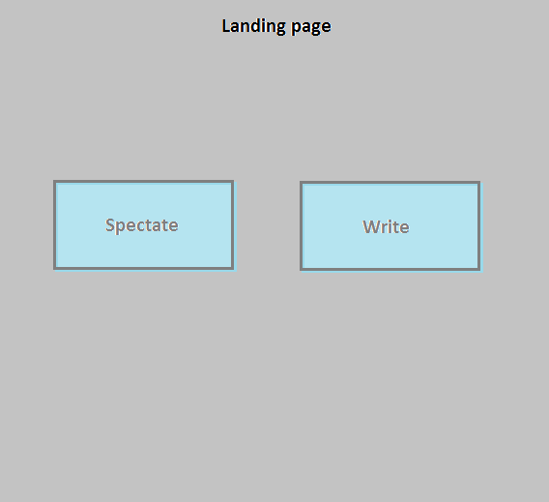

Page 2 – Spectating page

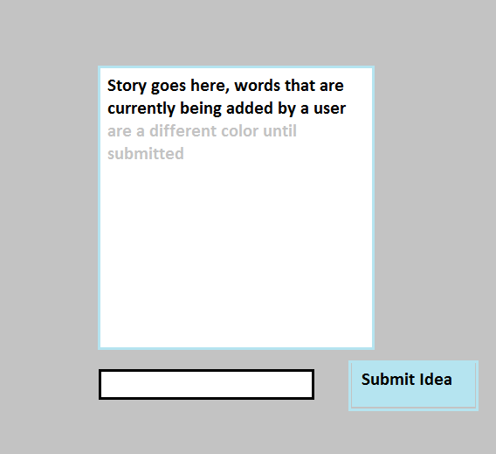

Page 3 – Editing page

